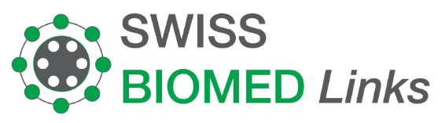
Invoice 002211
25.11.2022

Ms. Nadine Putri Dwirintha  PT Praba Cipta Mandiri  Pondok Indah Office Tower 3,Lt. 18  JI. Sultan Iskandar Muda Kav. V-TA  Pondok Pinang  Kebayoran Lama  12310 Jakarta Selatan  Indonesia |  | Lily Boeschlin  Swiss Biomed Links  Hardeggerstrasse 22  3008 Bern

Description | Amount in CHF
10 x Immun-Intercell Akut 60 Kapseln  10 x Omegan 750 120 Kapseln  10 x C-Intercell 650 mg Vitamin C  5 x Ozempic DualDose  1 x Femannose N 30 Portion  10 x Laetia 56 Kapseln  5 x Ralaxane 60 comprimés  5 x Iberogast 50 ml  3 x Procto Glyvenol 30 g  2 x Allsan 100 Stück  1 x Motilicum 10 mg  2 x Alkala T 10 Tabletten | 649.00  48.20  146.25  118.00  50.25  39.80  24.50  55.80
Amount Total

Thank you very much for your trust!

Account Name: Swiss BIOMEd Boeschlin Links
Bank: Berner Kantonalbank AG
3001 Bern, Switzerland
Account/IBAN: CH16 0079 0016 6050 1091 1
SWIFT: KBBECH22
Bank clearing no.: 790

