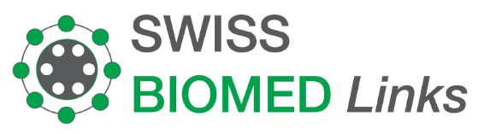
Invoice 55H-002208
19.07.2022

PT. Multi Sarana Prima Nusantara  Jl Boulevard Artha Gading Komp.  Ruko GBI Blok P20  Jakarta 14240  Indonesia |  | Treatment by  PD. Dr. med. Rainer Arendt  SwissMed. Clinic  Feldeggstrasse 26  Zürich

Description | QTY | Amount in CHF
Patient : Ng Ko Tjai. 21.02.1967  Gut Microbiome Therapy, 1 transplantations | 1 | 8'647.98
Amount total |  | 8'647.98

Thank you very much for your trust!

Account Name: Swiss BIOMEd Boeschlin Links
Bank: Berner Kantonalbank AG
3001 Bern, Switzerland
Account/IBAN: CH07 0079 0016 5898 0874 8
SWIFT: KBBECH22
Bank clearing no.: 790

