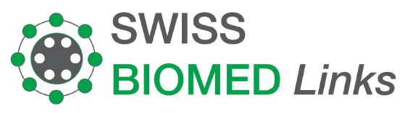
Packing List 55H-002208
25.11.2022

PT Praba Cipta Mandiri  Indah Office Tower 3, Lt. 18, JI.  Sultan Iskandar Muda Kav. V-TA  Pondok Pinang,  Kebayoran Lama, 12310  Indonesia |  | Lily Boeschlin  Swiss Biomed Links  Hardeggerstrasse 22  3008 Bern

Description | Amount in CHF
- Mr. Gene Tan  Gut microbiome therapy - 4 transplantations  - Mr. Theresia Tan  Gut Microbiome therapy - 4 transplantations  Discount  Infusion serums :  1 x Bosvene Akba @ 249 eur  2 X Methylsulfonylmethan @73.80 eur  3 X Hydroxyprolin @46.70 eur  6 x Resveratrol @ 226.10 eur  4 x Oliphenolia @ 249.00 eur  4 x Nicotinamide @ 67.00 eur  2 x Epinative @76.30 eur | 27’650.00  27’650.00  -8’295.00  249.00  147.60  140.10  1’356.60  996.00  268.00  152.60
Amount total  Amount in Euro | 50'314.90  50'750.60

Thank you very much for your trust!

Account Name: Swiss BIOMEd Boeschlin Links
Bank: Berner Kantonalbank AG
3001 Bern, Switzerland
Account/IBAN: CH16 0079 0016 6050 1091 1
SWIFT: KBBECH22
Bank clearing no.: 790

