Shipper’s Letter Head

Date : April 5th 2023
To.:
Kantor Bea Cukai
Soekarno-Hatta International Airport
Jakarta, Indonesia.

Dear Sir,
There was administration error on the House Airway Bill No. 6A304W34PQM/406-79264721 Dated on March 1st 2023, the packages was supposed to send to this consignee :

Swiss Biomed Boeschlin Links
Hardeggerstrasse 22
3008 Bern
Switzerland
Tel: +41 789 44 8966

Thank You
Your Sincerely,

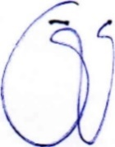
Lily Boeschlin
Sign and company stamp.

