

Bern, 7th June 2023

Subject of the letter: Medical Appointment Confirmation

To whom it may concern,

This is to confirm that the following appointment is reserved for Mrs. Juliati Sapta Dewi Magdalena at University
Hospital Zürich.

Date: Tuesday, 20th June 2023

Time: 11:00 am
Department: Reproduction endocrinology
Attending physician: Prof. Dr. med. Brigitte Leeners

For any questions, please do not hesitate to contact me at +41 78 948 966

Kind regards
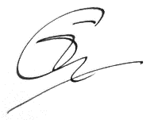
Lily Boeschlin

