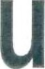
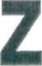

Universitäts Spital Zürich

Universitätsspital Zürich
WEST A 9, 8091 Zurich, Switzerland

Mrs. Juliati Sapta Dewi Magdalena Wife of Chief of the Indonesian National Police Jakarta
Indonesia

Confirmation
Natalia Müller
Patient Relations Manager

University Hospital Zurich International Office Rämistrasse 100
8091 Zürich

Direct +41 44 255 54 54
natalia.muelIer@usz.ch

This is to confirm that the following appointments are reserved for Mrs. Kiki Redjeki at University hospital Zurich.

Date: Thursday, 02.03 2023

Time: 09:30 am
Department: Reproduction Endocrinology
Attending physician: Prof. Dr. med. Brigitte Leeners

Time: 11:00
Department: Immunology
Attending physician: Dr. med. Lukas Frischknecht

Time: 4:00 pm Department: Gynecology
Attending physician: PD Dr. med. Gian-Piero Ghisu

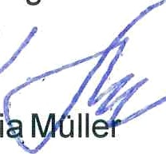
Should any questions arise, please do not hesitate to contact me. Kind regards
Natali III

