

Bern, 27.03.2023

RE: Return letter from shipper
Dear Sir or Madame,
Due to government import regulation, the recipient is not able to receive her parcel.
Therefore we would like to have the items return to us and shipper agrees to pay all charges.
Here is the relevant information:
-Tracking number 1Z6A304W0400288485
- Shipper Account: Swiss Biomed Links : 6A304W
- Address
Swiss Biomed Boeschlin Links
C/O Fam. Boeschlin
Hardeggerstrasse 22
3008 Bern
Switzerland
Tel: +41 76 804 58 31
Thank you very much in advance!
Yours Sincerely,
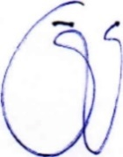
Lily Boeschlin

