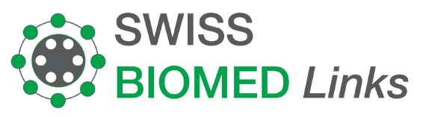
Invoice 55H-002103-5
07.02.2022

Wisnu Suhardono  Jl Daha I no. 2  South Jakarta  Indonesia |  | Treatment by  PD Dr. med. Rainer Arendt  SwissMed Clinic  Feldeggstrasse 26  8008 Zürich

Description |  | Amount
Ms. Sunarti SE
Gut Microbiome Therapy, 8 transplantations | SGD | 21’000.00
RNA 8 serum vials  Detoxification – Infusion  Ms. Hermawati  Gut Microbiome Therapy, 8 Transplantations  Gut Microbiome Therapy, 1 Transplantations Complementary  RNA 8 serum vials  Detoxification – Infusion  Mr. Wisnu SUhardono Complementary  Gut Microbiome Therapy, 4 transplantations  RNA 12 serum vials  Detoxification – Infusion | SGD  SGD  SGD  SGD  SGD  SGD  SGD  SGD  SGD | 1’150.00  1207.00  21'000.00  2’275.00  2’406.00
Amount total | CHF | 49’038.00

Thank you very much for your trust!

Bank details
Account Name: Artini
Bank: UOB Bank
Account no: 217-142-8426 313 Orchad Road
Adress: 313 Orchad Road
#01-35/36 313
@Somerset
Singapore 238895
SWIFT: UOVBSGSG

